🔹 Assignment 1: Permanent Table
Goal: Test persistence, Time Travel & recovery
Tasks:
- Create a permanent table EMP_PERM
CREATE OR REPLACE TABLE EMP_PERM (
EMP_ID NUMBER,
EMP_NAME STRING,
DEPT STRING,
SALARY NUMBER,
JOIN_DATE DATE
);
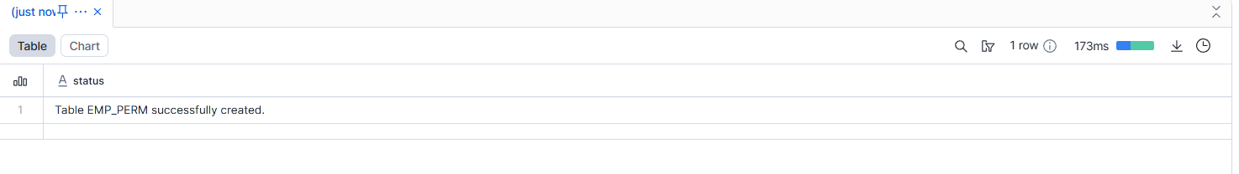
- Insert minimum 5 records
INSERT INTO EMP_PERM VALUES
(1, 'Ravi', 'IT', 60000, '2022-01-10'),
(2, 'Kiran', 'HR', 45000, '2021-05-15'),
(3, 'Anita', 'IT', 70000, '2020-11-20'),
(4, 'Suresh', 'FIN', 55000, '2019-03-12'),
(5, 'Meena', 'ADMIN', 40000, '2023-06-01');
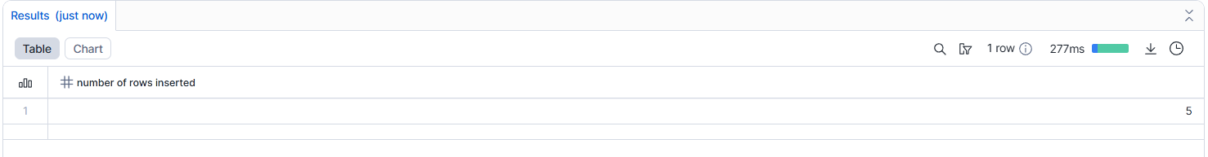
- Logout and login again
- Verify data persists
select * from emp_perm;
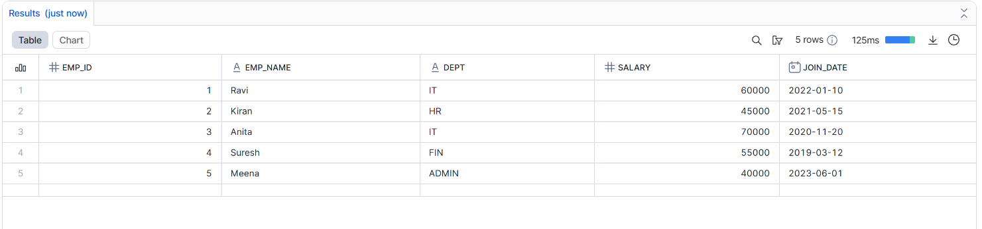
- Delete 2 records
DELETE FROM EMP_PERM
WHERE EMP_ID IN (2, 4);
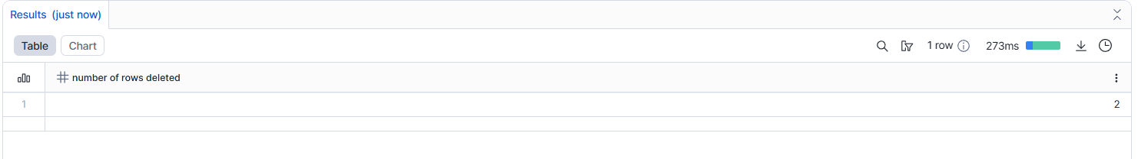
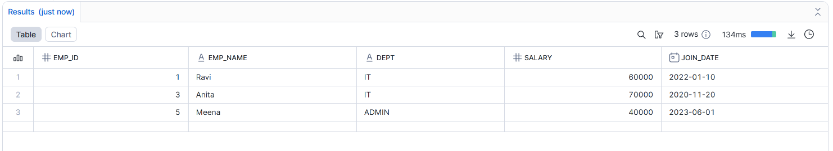
- Query deleted data using Time Travel
SELECT *
FROM EMP_PERM
AT (OFFSET => -500);
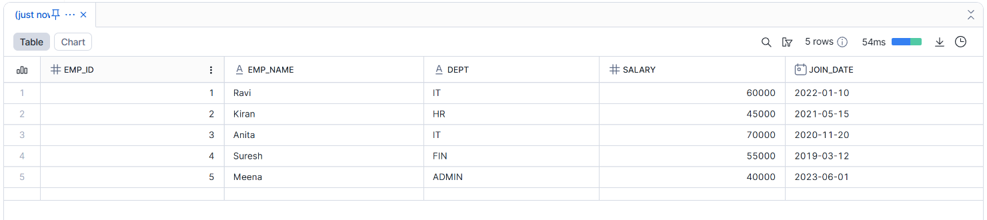
- Restore deleted data

- Drop the table
DROP TABLE EMP_PERM;
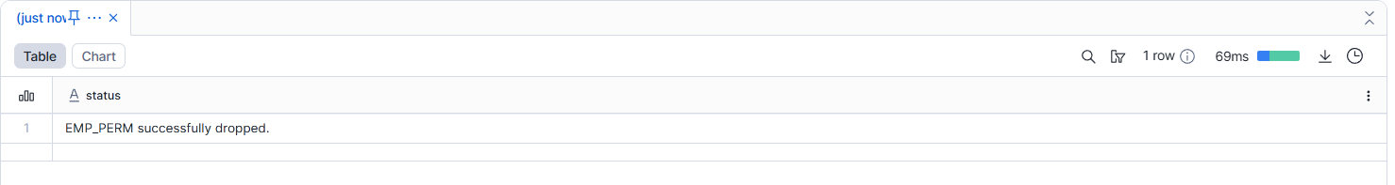
- Recover using UNDROP TABLE
UNDROP TABLE EMP_PERM;
select * from emp_perm;

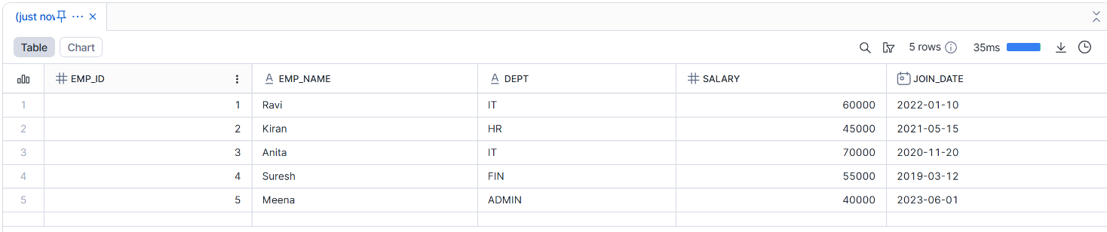
--------------------------------------------------------------------------------------------------------------------------
🔹 Assignment 2: Temporary Table
Goal: Test session-based background cleanup
Tasks:
- Create temporary table EMP_TEMP
CREATE OR REPLACE TEMPORARY TABLE EMP_TEMP (
EMP_ID NUMBER,
EMP_NAME STRING,
DEPT STRING,
SALARY NUMBER
);
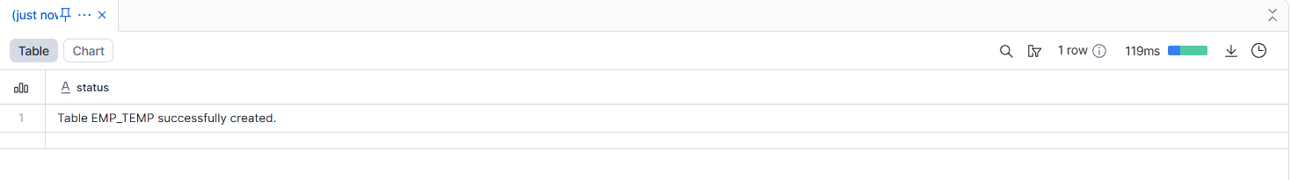
- Insert records
INSERT INTO EMP_TEMP VALUES
(1, 'Ravi', 'IT', 60000),
(2, 'Kiran', 'HR', 45000),
(3, 'Anita', 'IT', 70000);
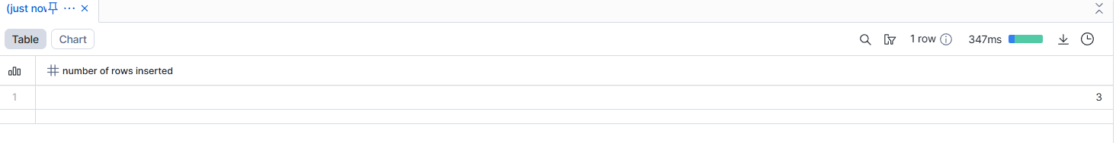
- Query data successfully
SELECT * FROM EMP_TEMP;
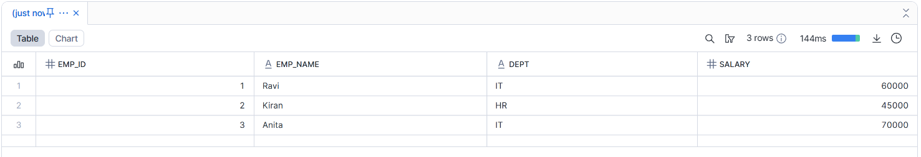
- End the session
- Reconnect and query the table
--------------------------------------------------------------------------------------------------------------------------------------
Assignment 3: Transient Table
Goal: Test limited retention behavior
Tasks:
- Create transient table EMP_TRANS
CREATE OR REPLACE TRANSIENT TABLE EMP_TRANS (
EMP_ID NUMBER,
EMP_NAME STRING,
DEPT STRING,
SALARY NUMBER
);
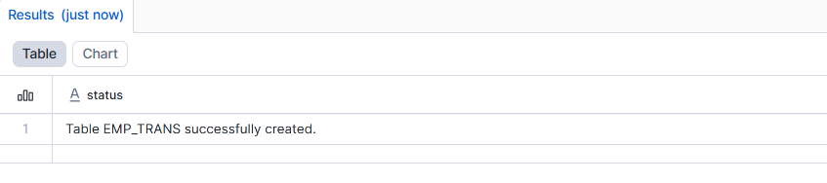
- Insert records
INSERT INTO EMP_TRANS VALUES
(1, 'Ravi', 'IT', 60000),
(2, 'Kiran', 'HR', 45000),
(3, 'Anita', 'IT', 70000),
(4, 'Suresh', 'FIN', 55000);
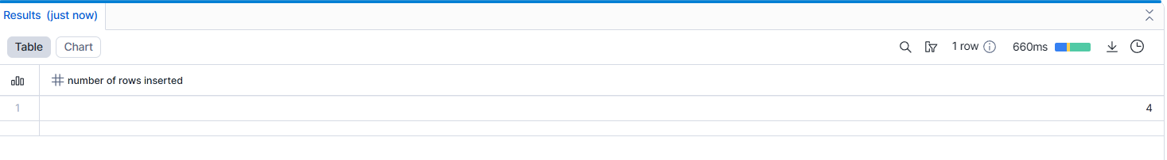
- Delete records
DELETE FROM EMP_TRANS
WHERE EMP_ID IN (2, 4);
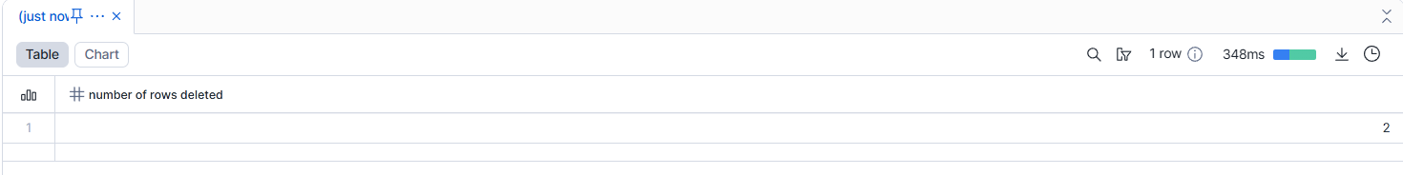
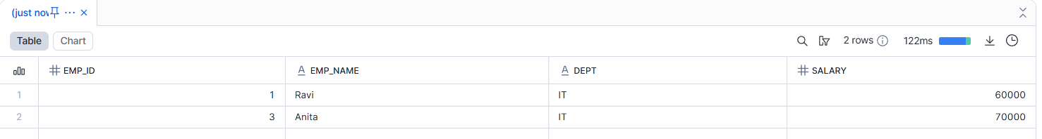
- Query data using Time Travel (within retention)
SELECT *
FROM EMP_TRANS
AT (OFFSET => -300);
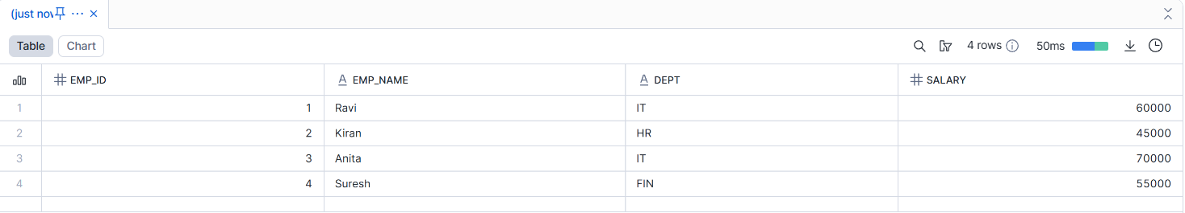
- Drop the table
DROP TABLE EMP_TRANS;
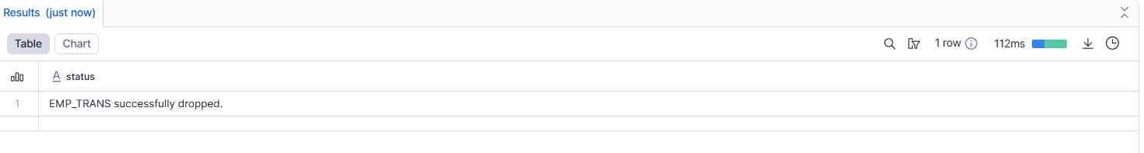
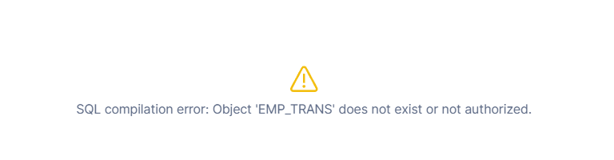
- Attempt recovery after retention period
UNDROP TABLE EMP_TRANS;
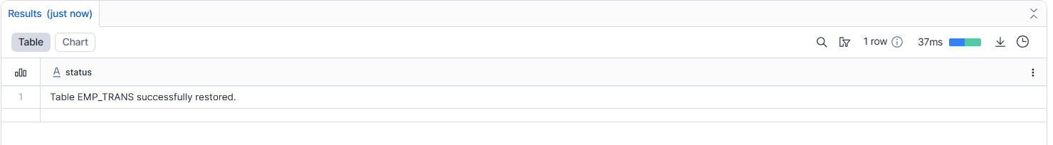
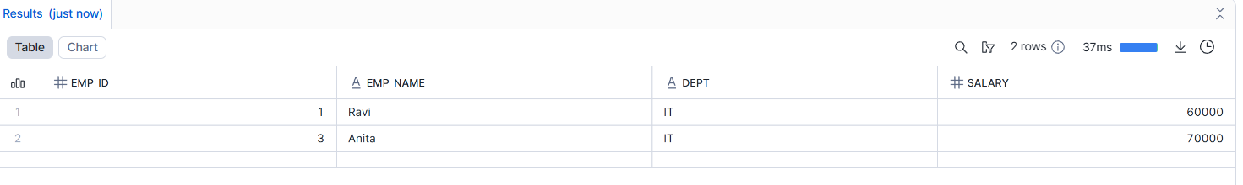
--------------------------------------------------------------------------------------------------------------------------------------
🔹 Assignment 4: CTAS (Create Table As Select)
Goal: Test background data transformation
Tasks:
- Create table EMP_HIGH_SALARY using CTAS
- Filter salary > 70,000
- Add calculated column SALARY_GRADE
- Drop source table
- Verify CTAS table still exists
--------------------------------------------------------------------------------------------------------------------------------------
🔹 Assignment 5: Table Cloning
Goal: Test zero-copy cloning
Tasks:
- Clone EMP_PERM as EMP_CLONE
CREATE OR REPLACE TABLE EMP_CLONE CLONE EMP_PERM;
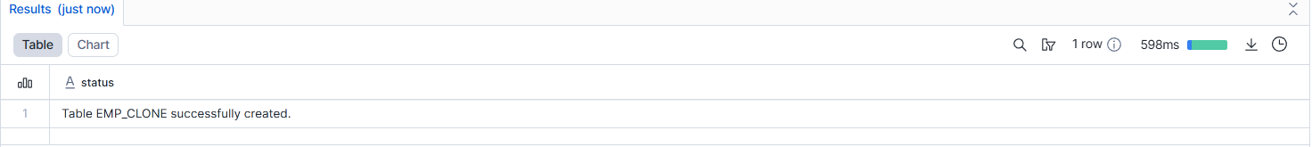
- Update data in cloned table
UPDATE EMP_CLONE
SET SALARY = SALARY + 5000
WHERE DEPT = 'IT';
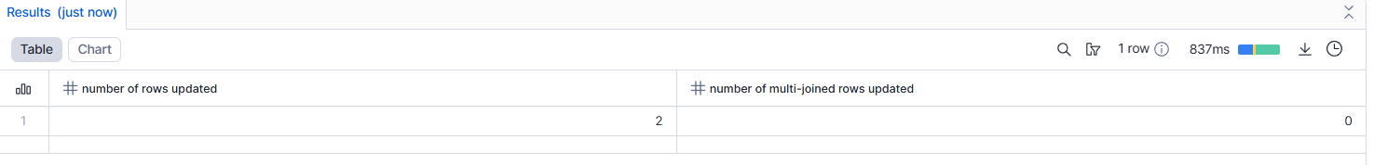
- Compare original vs clone
Original table
SELECT EMP_ID, EMP_NAME, DEPT, SALARY
FROM EMP_PERM
ORDER BY EMP_ID;
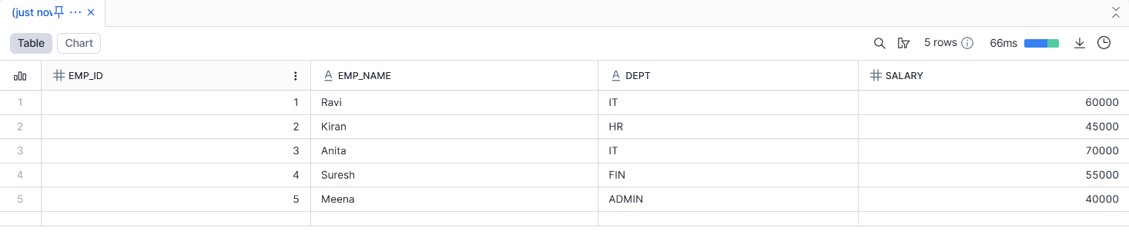
Cloned table
SELECT EMP_ID, EMP_NAME, DEPT, SALARY
FROM EMP_CLONE
ORDER BY EMP_ID;
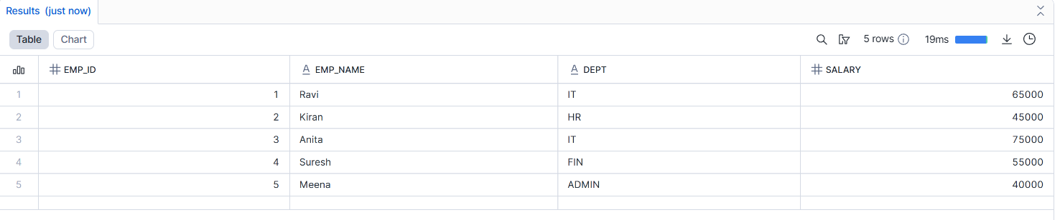
--------------------------------------------------------------------------------------------------------------------------------------
🔹 Assignment 6: Time Travel Testing
Goal: Test point-in-time recovery
Tasks:
- Perform DELETE on any table
DELETE FROM EMP_PERM
WHERE DEPT = 'HR';
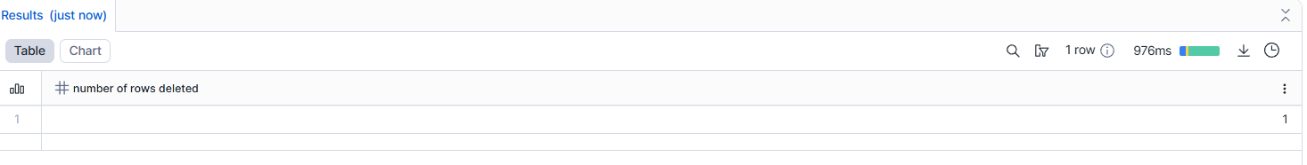
- Query using:
  - AT OFFSET
SELECT *
FROM EMP_PERM
AT (OFFSET => -120);
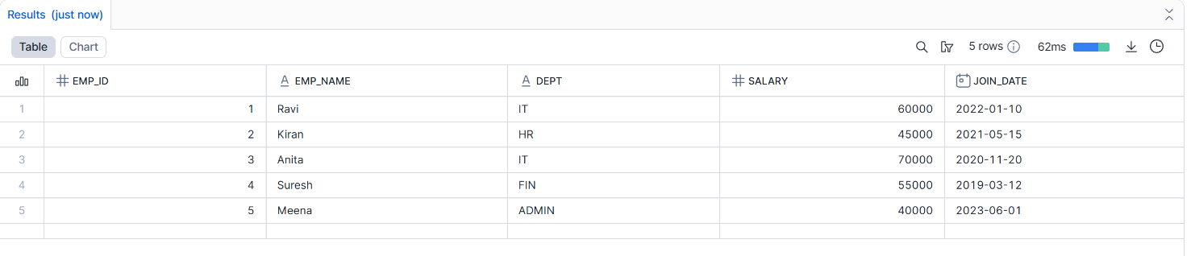
  - AT TIMESTAMP
SELECT *
FROM EMP_PERM
AT (TIMESTAMP => '2025-12-19 10:30:00');
- Restore deleted data
CREATE OR REPLACE TABLE EMP_PERM AS
SELECT *
FROM EMP_PERM
AT (OFFSET => -120);
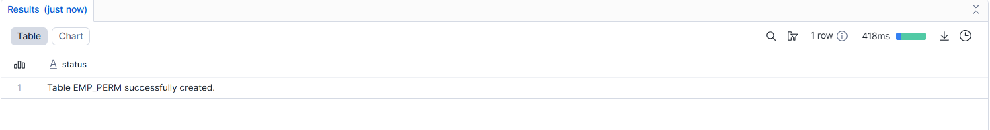
--------------------------------------------------------------------------------
🔹 Assignment 7: Drop & Purge Behavior
Goal: Compare cleanup rules
Tasks:
- Drop Permanent table and recover it
DROP TABLE EMP_PERM;
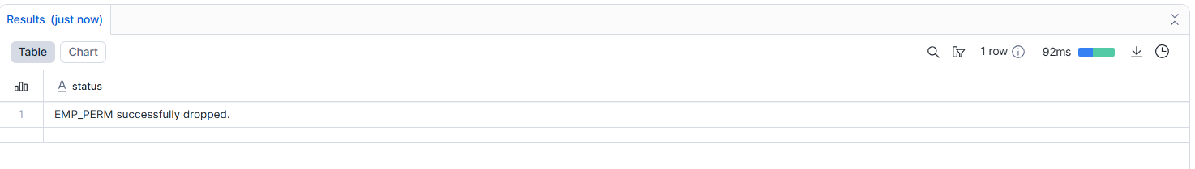
Recover using UNDROP
UNDROP TABLE EMP_PERM;
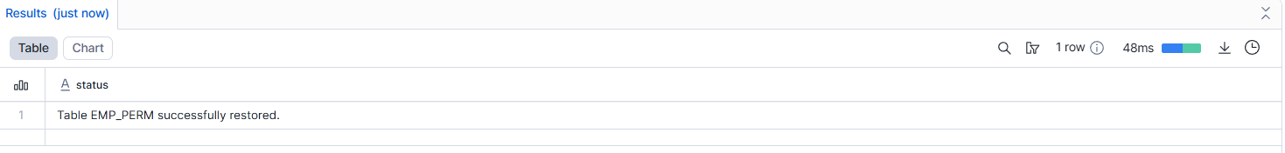
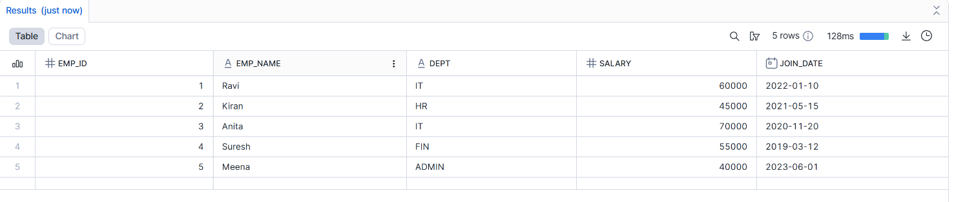
- Drop Transient table and attempt recovery
DROP TABLE EMP_TRANS;
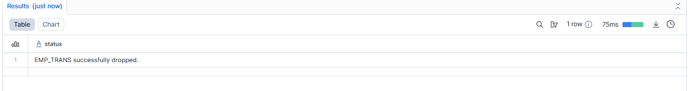
Attempt Recovery
UNDROP TABLE EMP_TRANS;
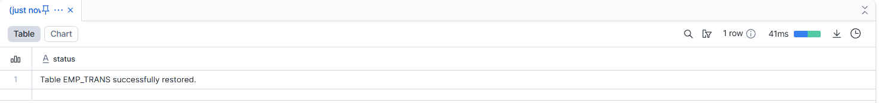
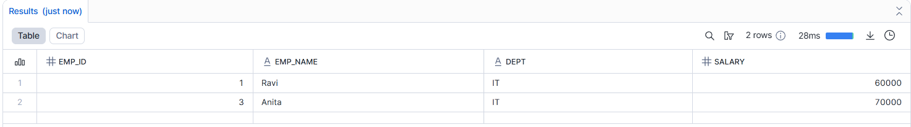
- Drop Temporary table and verify immediate removal
DROP TABLE EMP_TEMP;
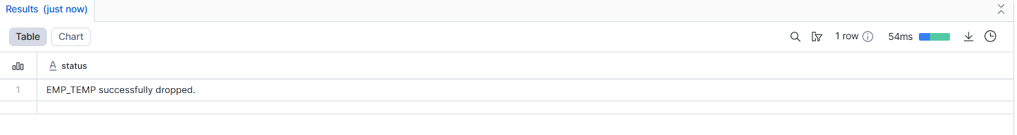
SELECT * FROM EMP_TEMP;


